Toronto Bicycling Network
Wolf Den Hostel and Nature Retreat
Cross Country Ski and Snowshoe Weekend Getaway
February 20 to 22, 2015:

Stay at the rustic Wolf Den Bunkhouse ‘n Cabins close to the entrance of Algonquin Park from Friday evening until Sunday. Enjoy the company of fellow enthusiasts while reveling in and celebrating the end of the winter season.

We have the entire Hostel booked for the weekend. There are three buildings. The Main Lodge building has washrooms, showers, cooking, and eating facilities and well as bedrooms down stairs. There are also two split winterized cabins (Loon and Bear).

The Loon and Bear cabins do not have washrooms or running water. You must go to the Main Lodge for washrooms and showers. The washrooms, in the Main Lodge, are right next to the front door and will not disturb anyone if used in the middle of the night.

You can choose a bed for yourself and your friends when signing up. View the room and bed layout graphic below. Go to the TBN website and view the Wolf Den web page for the updated rooming list showing who is staying where. It will be updated as often as possible.

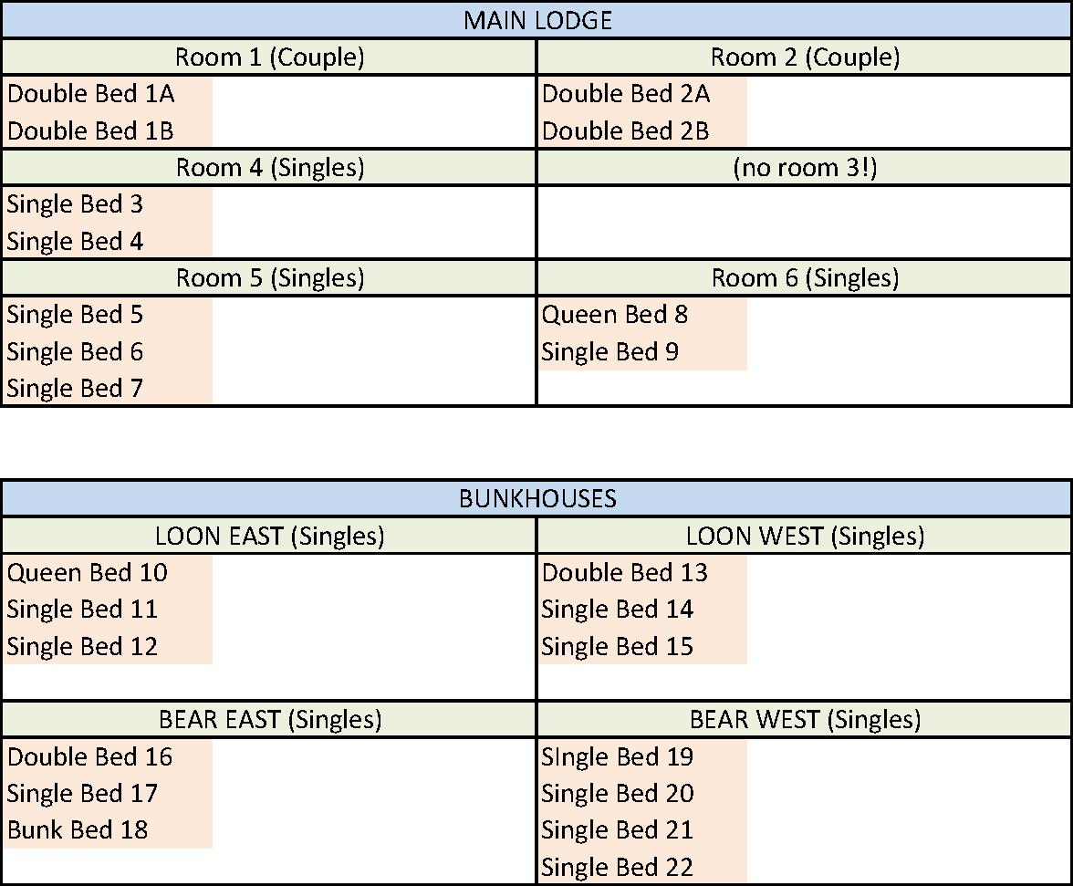
Provided will be Friday night snacks, two pancake breakfasts, and supplies for two sandwich style lunches. Saturday night dinner will be potluck. The closest urban centre is Huntsville on Hwy 60 if you are hungry when arriving Friday night or want to have dinner before driving back home Sunday. “3 Guys and a Stove” or “That little place by the lights” are popular Sunday night dinner spots. They need to be reserved though.

The area offers cross country skiing, snow shoeing, and hiking. The hostel is a 20 minute walk to Rustic Falls on the Oxtongue River for snow shoeing. The Beetle Lake Trail and nearby cross country trails are another hiking/snowshoeing option within walking distance.

Many will choose to ski in Algonquin Park ($16 per vehicle per day – car pooling reduces costs). Algonquin Park has three trail networks specifically designed and reserved for cross-country (nordic) skiing. Two trails are packed and groomed on a regular basis and one wilderness ski trail is offered, where no grooming takes place.
- Fen Lake Ski Trail
- Leaf Lake Ski Trail
- Minnesing Wilderness Ski Trail (not groomed)

Arrowhead Provincial Park and the Frost Centre Trails are both nearby and popular cross country and snow shoeing destinations.

For snowshoeing in Algonquin Park, any of the Hwy 60 corridor hiking trails can be used in winter. The 5km Booth Rock trail becomes 7 km in winter since the road is not ploughed. The 10km Centennial Trail becomes 14 km in winter.

Please register online, or print and complete the last section of this form. Send it along with a cheque or money order for $95 (or $105 if you are not a TBN member) made payable to the “Toronto Bicycling Network”. Please do not send cash through the mail.

If you are using mail, please send the form with payment to:
Paul Price
7 – 6449 Glen Erin Drive
Mississauga, ON
L5N 2T2

When you register, you will receive a confirmation email (or regular mail) with an attachment providing directions to the hostel, an itinerary, and more suggestions on what to bring.

While we will not organize car pooling, we will help in the process. Contact us for more information.

The hostel is about a three hour drive north of Toronto on Highways 400, 11, and 60.

Because of the facility and the options available in the area, this is an “all weather” weekend trip. We don’t think you’ll find a better deal for a weekend getaway.

Suggestions on what to bring for the weekend:

Potluck Dinner: - Saturday night dinner is a group effort, bring a dish you wish to share.

Bathing suit – there is a sauna cabin.

BYOB – alcohol is welcome if you are so inclined

Slippers – Shoes are removed in the foyer of the Main Lodge

Skiis and appropriate clothing (do we need to mention this?)

What not to bring:

Bottled Water – the hostel suggests using their “beautiful UV filtered water”

Plates, cups, and cutlery – the hostel has everything you need

Bedding, linens, comforters, and towels – these are provided by the Hostel

paul price, & Brenda Sweet
905-567-1035 (home – no voicemail)
wolfden@tbn.ca

Toronto Bicycling Network
Wolf Den Weekend Getaway
February 20 to February 22, 2014

Name: __________________________________________________________
Gender: M / F (sorry, it’s not always obvious from the name)
Phone Number: __________________________________________________________
TBN Member? Yes / No
Correspondence: Email / Mail (if mail, we will need your address)
Email or Address: __________________________________________________________
__________________________________________________________
Do you need a ride (carpooling)? Yes / No
Can you help by providing transportation to someone? Yes / No
If yes, what intersection are you close to: _______________________________________
If you are offering or asking for a ride, what time were you thinking of leaving: _____________
Bed Preference (check TBN website for beds remaining): 1 ___________, 2 ____________
I would like to be in the same room with: ___________________________________________________

Food Restrictions: Vegetarian Pork Free Gluten Free Peanut Allergy
Other: ________________________________________

I agree to the terms of the TBN waiver on the next page Yes / No
Comments: __________________________________________________________
__________________________________________________________
__________________________________________________________
__________________________________________________________
__________________________________________________________
__________________________________________________________

Waiver:

I HEREBY RELEASE AND FOREVER DISCHARGE the Toronto Bicycling Network Inc., their officers, directors, employees, agents and other representatives ("Released Parties"), from all claims, demands, and causes of action, whether in law or equity, in respect of death, injury, loss or damage to my person, the registrant undersigned for whom I am the parent or guardian (The Registrant) or property however arising as a result of my participation or the participation of The Registrant in any activity organized and/or sponsored by this TBN organized weekend trip. I understand that this release includes the release of all claims, demands and causes of action, which may arise by reason of any intentional act, negligence, gross negligence, error or omission on the part of the Released Parties. I declare that this release is binding upon me, my heirs, executors, administrators, and assigns, and those of The Registrant. I FURTHER UNDERTAKE TO HOLD AND SAVE HARMLESS AND AGREE TO INDEMNIFY the RELEASED PARTIES from and against any and all liability incurred by any or all of them arising as a result of, or in any way connected to, my participation or the participation of The Registrant in any activity organized and/or sponsored by the TBN. BY SIGNING THIS AGREEMENT I ACKNOWLEDGE HAVING READ, UNDERSTOOD, AND AGREED to the above RELEASE AND INDEMNITY. I WARRANT that I am at least 18 years of age, physically fit to participate in this weekend trip, and that all my equipment is mechanically fit and suitable for its intended use in such activities, and that I shall heed all traffic laws and wear a CPSC-, CSA-, SNELL-, or ANSI-approved cycling helmet.

Rev. 002, 3 June 2013

